Noah’s Ark Early Learning Centre Enrolment Form
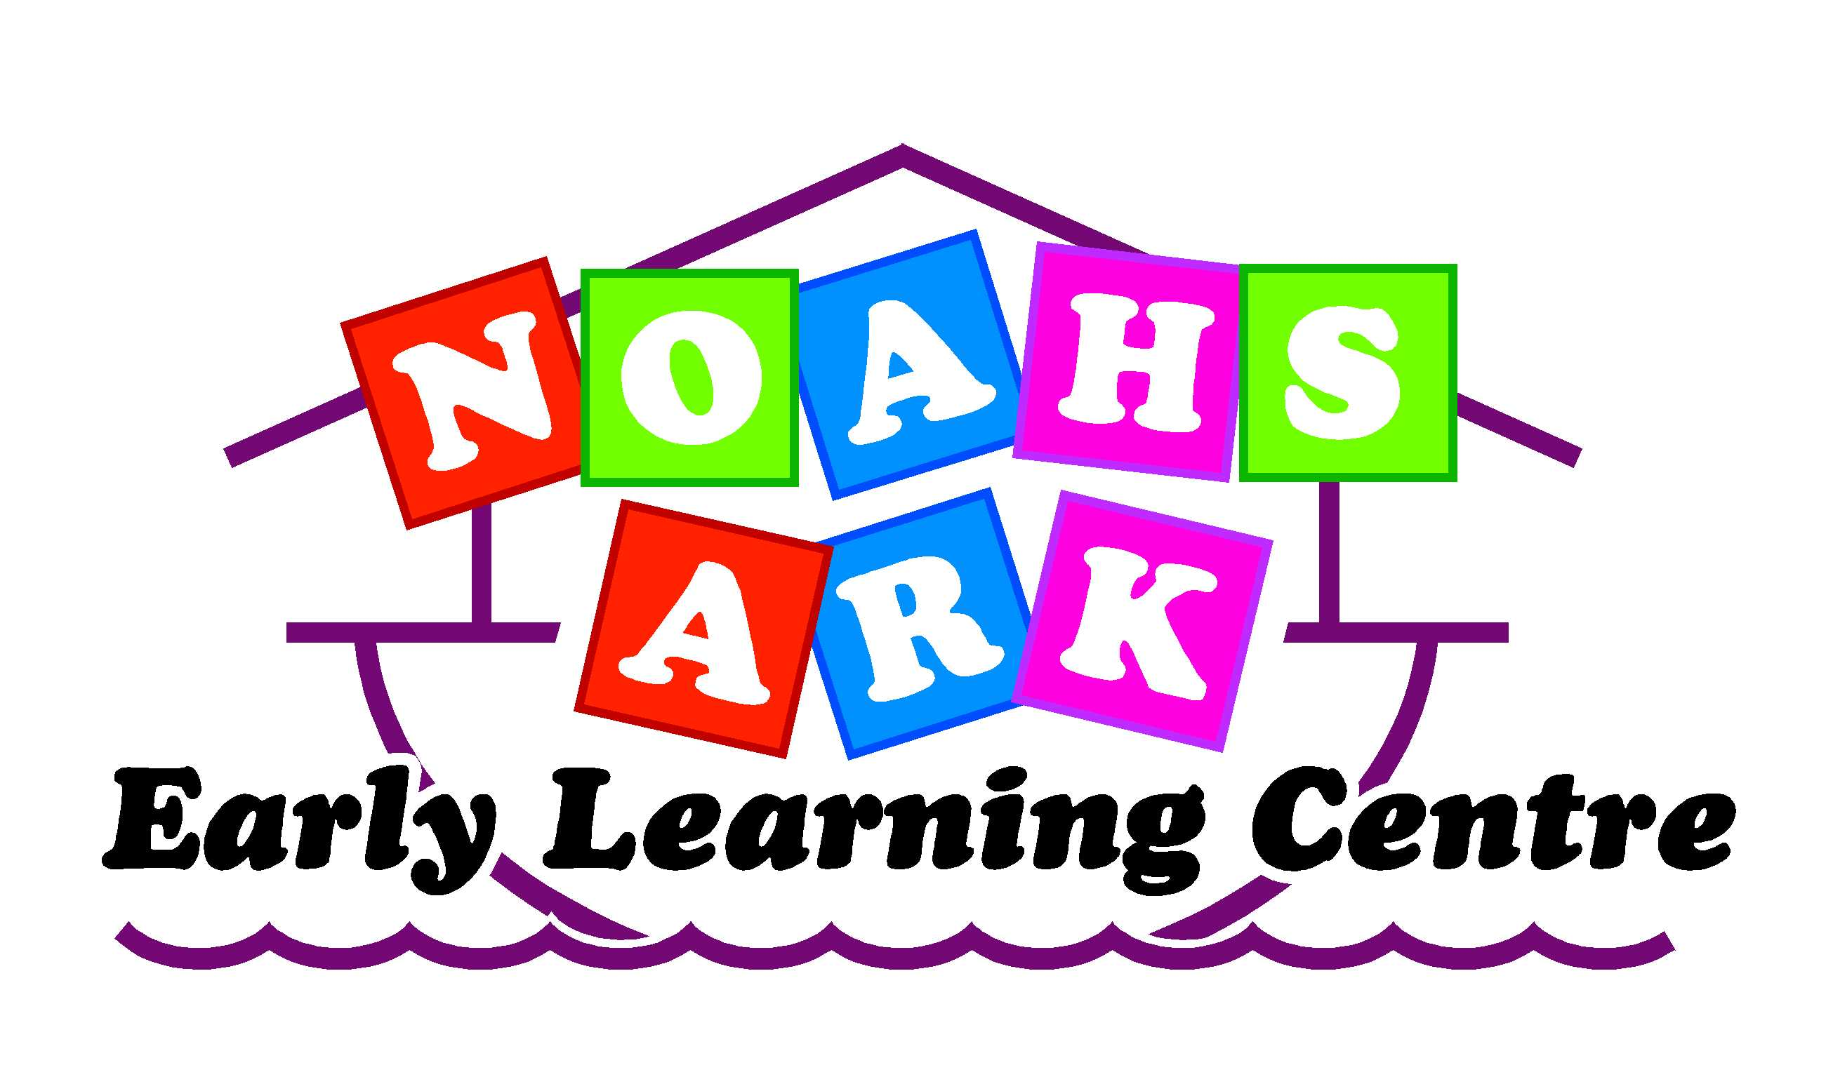
19 Tawa Street
Gonville
Whanganui
Ph 06 347 7941
⧫ Child’s details:
Child’s official surname or family name:
Child’s official given name:
Child’s official other names / middle names:
(please separate names with a comma):
Name your child is known by / preferred name:
Surname / family name: Given name:
Copy of official identity verification document* collected by staff:
❑ New Zealand birth certificate   New Zealand passport   Other ____________________________________ |  | ❑ Foreign birth certificate   Foreign passport  Staff initials: _______________
Child’s date of birth: / / |  |  |  |  |  | Male |  | Female
Child’s ethnic origin/s:  ___________________________  ___________________________  ___________________________ | Iwi your child belongs to:  ___________________________  ___________________________  ___________________________ |  |  |  | Language/s spoken at home:  ___________________________  ___________________________  ___________________________
Child’s primary residential address:
Post Code:
⧫ Privacy Statement:
We are collecting personal information on this enrolment form for the purposes of providing early childhood education for your child.
We will use and disclose your child’s information only in accordance with the Privacy Act 1993. Under that Act you have the right to access and request correction of any personal information we hold about you or your child.
Details about your child’s identity will be shared with the Ministry of Education so that it can allocate a national student number for your child. This unique identifier will be used for research, statistics, funding, and the measurement of educational outcomes.
You can find more information about national student numbers at: www.minedu.govt.nz/parents
* Information about acceptable identity verification documents is available online at
www.lead.ece.govt.nz and www.minedu.govt.nz/parents.
The Ministry recommends that all services keep a copy of the identity verification document of each child who is enrolled at the service.
Parents / Guardians:
1. Given names: |  | 2. Given names:
Surname / family name: |  | Surname / family name:
Address: |  | Address:
Post Code: |  | Post Code:
Guardians DOB |  | Guardians DOB
Phone (Home): |  | Phone (Home):
Employer: |  | Employer:
Phone (Work): |  | Phone (Work):
Phone (Mobile): |  | Phone (Mobile):
Email: |  | Email:
Relationship to child: |  | Relationship to child:
3. Given names: |  | 4. Given names:
Surname / family name: |  | Surname / family name:
Address: |  | Address:
Post Code: |  | Post Code:
Phone (Home): |  | Phone (Home):
Phone (Work): |  | Phone (Work):
Phone (Mobile): |  | Phone (Mobile):
Email: |  | Email:
Relationship to child: |  | Relationship to child:

Emergency contacts who can also pick up your child
Given names: | Given names:
Surname / family name: | Surname / family name:
Address: | Address:
Post Code: | Post Code:
Phone (Home): | Phone (Home):
Phone (Work):  Phone (mobile) | Phone (Work):  Phone (Mobile)
Relationship to child: | Relationship to child:
Custodial Statement
Are there any custodial arrangements concerning your child?
If YES, please give details of any custodial arrangements or court orders (a copy of any court order is required)
Person/s who cannot pick up your child:
Name: | Name:
Name: | Name:
Additional Emergency Contacts (also able to pick up child):
1. Given names: |  | 2. Given names:
Surname / family name: |  | Surname / family name:
Address: |  | Address:
Post Code: |  | Post Code:
Phone (Home): |  | Phone (Home):
Phone (Work): |  | Phone (Work):
Phone (Mobile): |  | Phone (Mobile):
Relationship to child: |  | Relationship to child:
Email: |  | Email:
3. Given names: |  | 4. Given names:
Surname / family name: |  | Surname / family name:
Address: |  | Address:
Post Code: |  | Post Code:
Phone (Home): |  | Phone (Home):
Phone (Work): |  | Phone (Work):
Phone (Mobile): |  | Phone (Mobile):
Email: |  | Email:
Relationship to child: |  | Relationship to child:
Child’s doctor:
Name: |  | Phone:
Name of medical centre:

Health
Illness

Allergies:

Is your child up-to-date with immunisations? |  |  | Tick One | Yes |  | No
(Please provide verification of all immunisations)
For staff: Immunisation records sighted and details recorded: |  |  | Tick One | Yes |  | No

Medicine
Category (i) Medicines
A category (i) medicine is a non-prescription preparation (such as arnica cream, antiseptic liquid, insect bite treatment) that is not ingested, used for the ‘first aid’ treatment of minor injuries and provided by the service and kept in the first aid cabinet.
Note: The service must provide specific information about the category (i) preparations that will be used.
Do you approve category (i) medicines to be used on your child? |  |  | Tick One | Yes |  | No
Name/s of specific category (i) medicines that can be used on my child, provided by service:
- Curash Powder | - Sunscreen
Parent/Guardian Signature: _____________________________ |  | Date: ____ /____ / ____

Category (ii) Medicines
Category (ii) medicines are prescription (such as antibiotics, eye/ear drops etc) or non-prescription (such as paracetamol liquid, cough syrup etc) medicine that is used for a specific period of time to treat a specific condition or symptom, provided by a parent for the use of that child only or, in relation to Rongoa Māori (Māori plant medicines), that is prepared by other adults at the service.
I acknowledge that written authority from a parent is to be given at the beginning of each day a category (ii) medicine is to be administered, detailing what (name of medicine), how (method and dose), and when (time or specific symptoms/circumstances) medicine is to be given.
Parent/Guardian Signature: _____________________________ | Date: ____ /____ / ____

Category (iii) Medicines
To be filled in if your child requires medication as part of an individual health plan, for example for an on-going condition such as asthma or eczema etc and is for the use of that child only.
For staff: Individual health plan sighted and a copy taken: Tick One: |  | Yes |  | No
Name of medicine:
Method and dose of medicine:
When does the medicine need to be taken: (State time or specific symptoms)
Parent/Guardian Signature: _____________________________ | Date: ____ /____ / ____

⧫ Enrolment Details:
Date of Enrolment:____ /____ / ___ |  | Date of Entry: ____ /____ / ____ |  |  |  | Date of Exit: ____ /____ / ____
Please Note: 20 Hours ECE is for up to six hours per day, up to 20 hours per week and there must be no compulsory fees when a child is receiving 20 Hours ECE funding (applies to 3 & 4 year olds only).
Days Enrolled: | Monday |  | Tuesday | Wednesday | Thursday |  | Friday
Times Enrolled: |  |  |  |  |  |  |  | Total hours:
For 20 Hours ECE fill out boxes below with the hours attested e.g. 6 hours
20 Hours ECE at this service |  |  |  |  |  |  |  | Total hours:
20 Hours ECE at another service |  |  |  |  |  |  |  | Total hours:
Parent/Guardian Signature: ____________________________ |  |  |  |  | Date: ____ /____ / ____

⧫ 20 Hours ECE Attestation: (3 & 4 year olds only)
- Is your child receiving 20 Hours ECE for up to six hours per day, 20 hours per week at this service?
Tick One |  | Yes |  | No
- Is your child receiving 20 Hours ECE at any other services? Tick One |  | Yes |  | No
If yes to either or both of the above, please sign to confirm that:
- Your child does not receive more than 20 hours of 20 Hours ECE per week across all services.
- Your authorise the Ministry of Education to make enquiries regarding the information provided in the Enrolment Agreement Form, if deemed necessary and to the extent necessary to make decisions about your child’s eligibility for 20 Hours ECE.
- You consent to the early childhood education service providing relevant information to the Ministry of Education, and to other early childhood education services your child is enrolled at, about the information contained in this box.
Parent/Guardian Signature: _____________________________ | Date: ____ /____ / ____

⧫ Dual Enrolment Declaration
I hereby declare that my child is/is not enrolled at another early childhood institution at the same times that he/she is enrolled at Noah’s Ark Early Learning Centre
Parent/Guardian Signature: _____________________________ | Date: ____ /____ / ____

⧫ Statutory Holidays / Term Breaks
This enrolment agreement is inclusive of school term breaks.
Noah’s Ark Early Learning Centre is not open on the following public holidays if they fall on a weekday. Please tick the days you wish your child to be specifically enrolled for:
New Year’s Day | x | Easter Monday | x | Christmas Day | x
Day after New Year’s Day | x | ANZAC Day | x | Boxing Day | x
Waitangi Day | x | Queen's Birthday | x | Local Anniversary Day | x
Good Friday | x | Labour Day | x

Required Information for Licensing Purposes
- Excursions: Permission for the child to take part in regular excursions (under the conditions stated in the service’s excursions policy), including spontaneous outings into the local community. YES/ NO (please delete one.
- Photo/video: permission for the child to be photographed for the purposes of assessment, planning and evaluation (explain clearly how the photos/videos can/can’t be used) YES/NO (please delete one).

Permissions
- Please indicate Yes/No your agreement to the following
- Do you give permission for your child to take part in spontaneous outings? Yes/No (please delete one)
- Photo/Video: Do you give permission for your child to be photographed for the purpose of assessment, planning and evaluation
By permanent staff Yes/No
By students Yes/No
- Website/Newsletter/Newspaper/Facebook. Do you give permission for your child’s photo to be placed on our public website/Facebook page, the local paper, and our centre newsletter? Yes/No (please delete one)
- Do you give permission for your child to have hearing and vision checks by the hearing and vision technician? YES/ NO (please delete one).

⧫ Parent Declaration
In the event of an accident or emergency, I authorise the centre to seek advice or treatment as it deems necessary in the best interest of my child.

I will adhere to the requirements and regulations of Noah’s Ark Early Learning Centre and will pay my fees by the due date. (7days) Any outstanding debt will be referred to a Debt Collection Agency at my cost.
By signing this Enrolment Agreement Form, I agree for my child to participate in all areas of the centre’s curriculum
I will provide two weeks’ notice of the cancellation of my child’s placement at the centre. Failure to do so will incur 2 weeks charges.

Under the credit reporting privacy code 2004 Noah’s Ark Early Learning Centre reserves the right to conduct a credit check.

I declare that all the above information is true and correct to the best of my knowledge.
Acceptance of enrolment of my child at this service is in no way an assurance or guarantee of continued enrolment for the time indicated or under the terms and conditions effective at the time of enrolment. Management reserves the right to terminate enrolment or vary the conditions.
Parent/Guardian Signature: _____________________________ | Date: ____ /____ / ____

⧫ Service Declaration
On behalf of Noah’s Ark Early Learning Centre I declare that this form has been checked and all relevant sections have been completed.
Service Provider Signature: _____________________________ | Date: ____ /____ / ____

Change of Days/Times of Enrolment: (Office Use)
Effective Date of Change: ____ /____ / ____
Days Enrolled: | Monday | Tuesday | Wednesday |  | Thursday | Friday
Times Enrolled: |  |  |  |  |  |  | Total
For 20 Hours ECE fill out boxes below
20 Hours ECE at this service
20 Hours ECE at another service
Parent/Guardian Signature: _____________________________ |  |  |  | Date: ____ /____ / ____

Change of Days/Times of Enrolment: (Office use)
Effective Date of Change: ____ /____ / ____
Days Enrolled: | Monday | Tuesday | Wednesday |  | Thursday | Friday
Times Enrolled: |  |  |  |  |  |  | Total
For 20 Hours ECE fill out boxes below
20 Hours ECE at this service
20 Hours ECE at another service
Parent/Guardian Signature: _____________________________ |  |  |  | Date: ____ /____ / ____

